**Self-declaration for Academic Integrity**

I declare that I am the originator of this work and that all other sources used in this work have been appropriately acknowledged and referenced.

I understand that plagiarism is the act of taking and using the whole or any part of another person’s work and presenting it as my own without proper acknowledgement.

I also understand that plagiarism is an academic offence and that the school may take disciplinary action against me for plagiarism.

Signature of Student

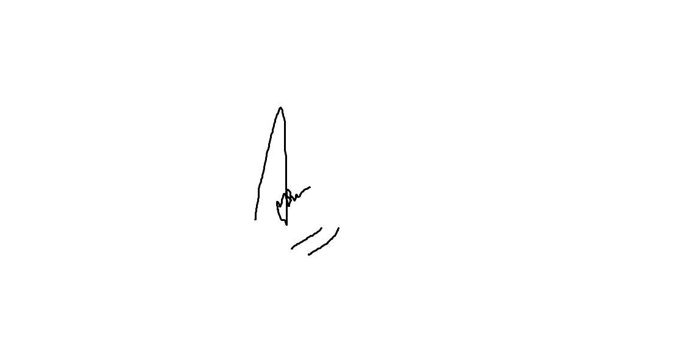

For details, the student may refer to the TP students’ handbook.